1. INTRODUCTION
1.1. Project Overview
IntelliSQL: Intelligent SQL Querying with LLMs using Gemini Pro is an intelligent system designed to simplify database interaction by allowing users to query databases using natural language. Many users find it difficult to write complex SQL queries because it requires knowledge of database syntax and structure. This project solves that problem by using Large Language Models (LLMs) to automatically convert human language into accurate SQL queries.The system allows archivists and administrators to upload, update, and maintain artifact records, while researchers, students, and educators can easily search and access artifact information through a user-friendly interface.
Overall, the project demonstrates how modern AI technologies like Gemini Pro can enhance traditional database systems, making them more accessible, intelligent, and efficient for a wide range of users. The system uses Gemini Pro to understand user questions, analyze the database schema, and generate optimized SQL queries.to give and best understandings queries.
1.2. Objectives
The main objectives of the intelligent sql querying with llms using gemini pro are:
- To develop an intelligent system that converts natural language queries into SQL queries.
- To integrate LLMS(Gemini Pro) for understanding user questions and database structure.
- To simplfy database access for non -technical users who do not know SQL
- To generate accurate and optimized SQL queries automatically
- To reduce the time and effort required to write complex database queries

2. IDEATION PHASE
2.1. Problem Statement
The problem is to develop a system that allows users to interact with databases using simple natural language instead of manually writing SQL queries. The system should be able to understand the user’s request, convert it into an accurate SQL query, execute it on the database, and return meaningful results. automatically translate natural language questions into SQL queries, making database access easier, faster, and more efficient for all types of users

Example:
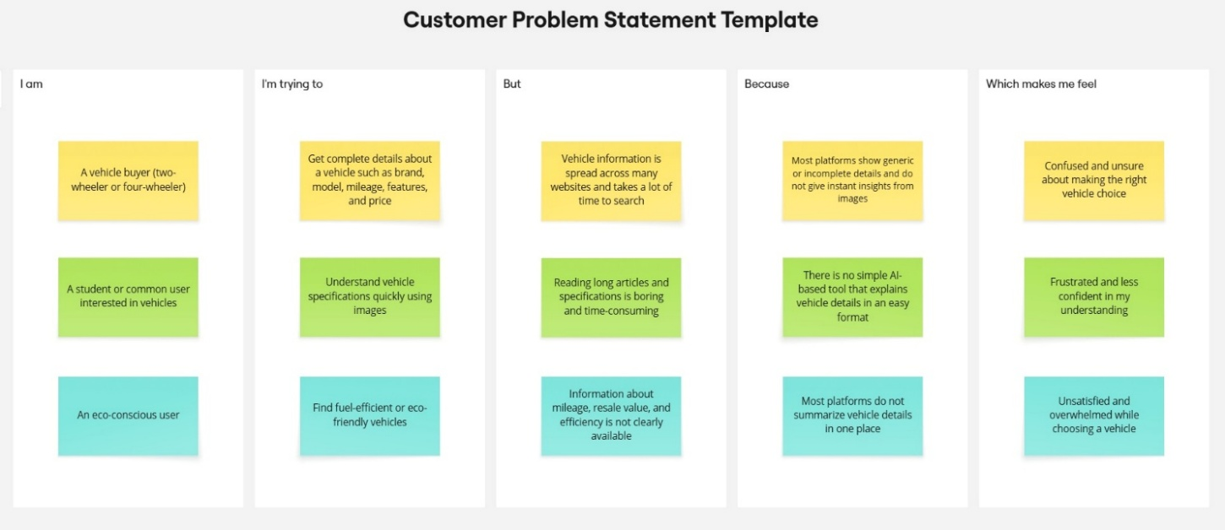

I am | I'm trying to | But | Because | Which makes me feel
A Data Analyst | Query database using natural language | Writing complex SQL queries takes time and requires strong SQL | Traditional database systems only understand structured SQL commands | Frustrated, slow in analysis, and dependent on technical experts
A Developer | Build smarter data applications | Integrating natural language with SQL database is complex | Traditional systems lack AI-powered query understanding | Challenged to provide user-friendly

2.2. Empathy Map Canvas

Empathy Map Canvas:

The IntelliSQL Empathy Map focuses on understanding the needs, challenges, and expectations of users who interact with databases but may not have strong knowledge of SQL. These users include students, data analysts, researchers, business professionals, and beginners in database management. Many users need information from databases but find it difficult to write correct SQL queries or understand complex database structures. They often look for a simpler way to access data without learning technical query languages.

Example:

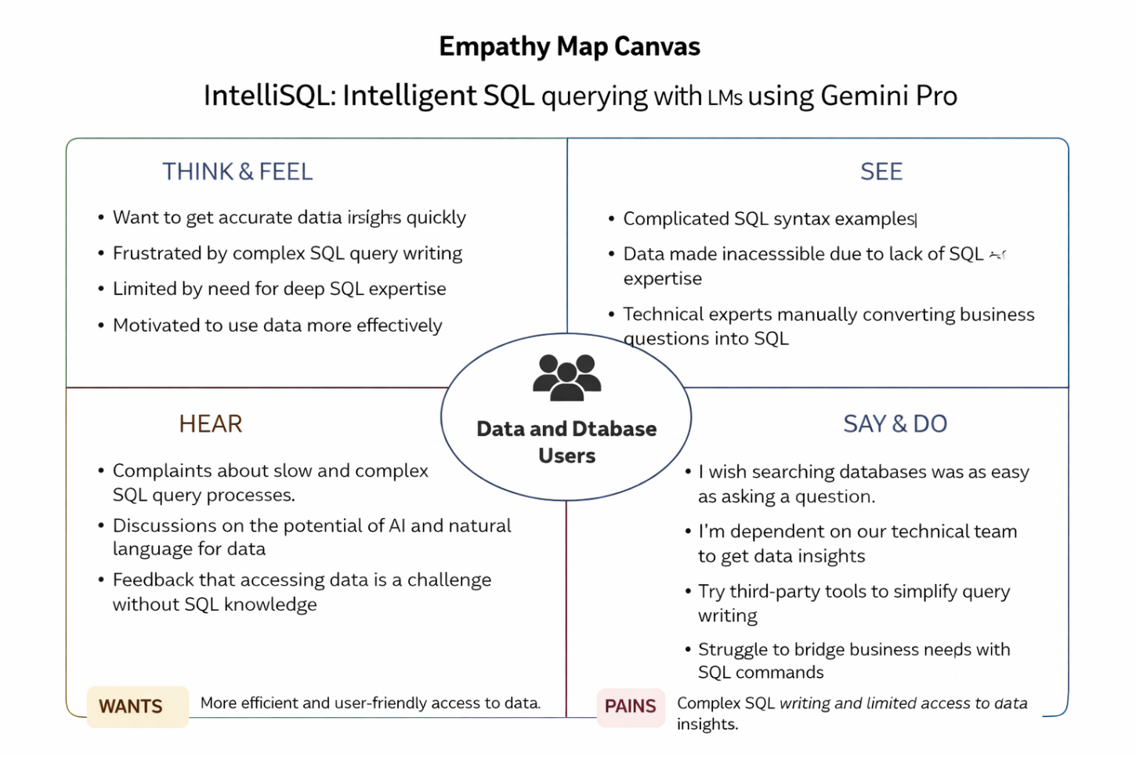

Example: intelligent sql querying with llms using gemini pro
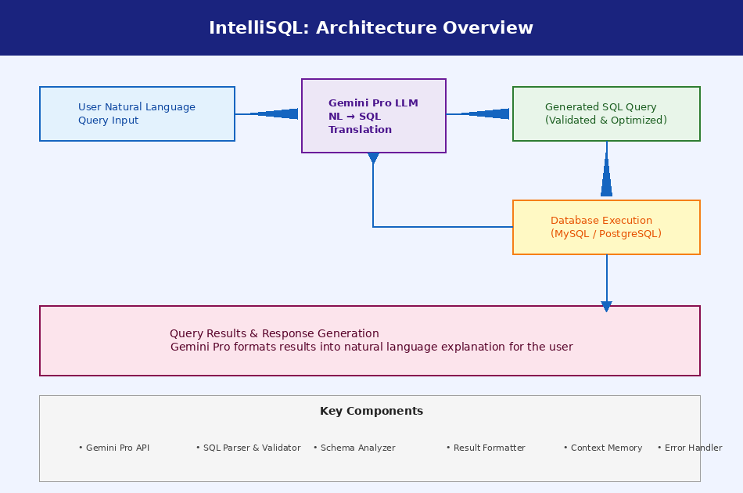

2.3 Brainstorming
Brainstorm & Idea Prioritization:
Brainstorming for “Gemini historical artifact description”:
Brainstorming for the project “IntelliSQL: Intelligent SQL Querying with LLMs using Gemini Pro” focuses on exploring how large language models (LLMs) can be used to translate natural language questions into accurate SQL queries. The main goal of this brainstorming session is to generate ideas on how IntelliSQL can assist students, developers, analysts, and businesses in querying databases without needing expertise in SQL syntax.
IntelliSQL can solve this problem by leveraging Gemini Pro’s advanced natural language understanding to interpret user queries and generate optimized SQL statements . The system will bridge the gap between non-technical users and relational databases by providing accurate, context-aware SQL generation along with query explanations and result summaries.
Step-1: Team Gathering, Collaboration and Select the Problem Statement:

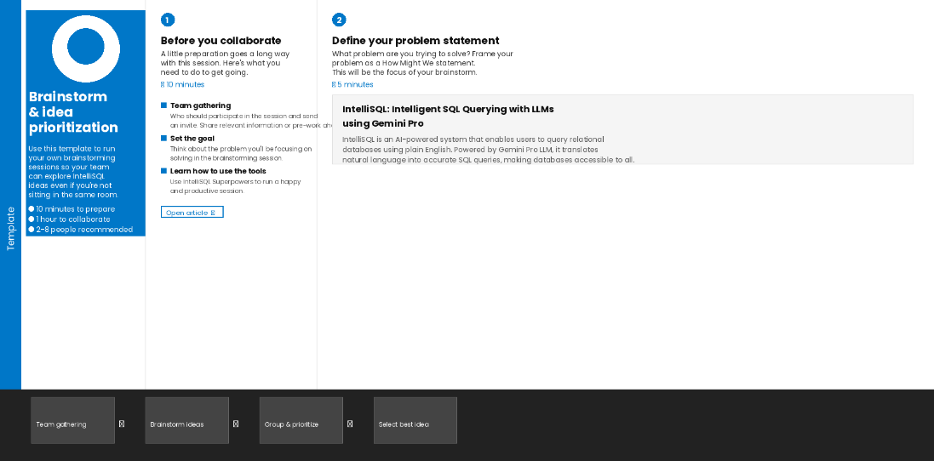

Step-2: Brainstorm, Idea Listing and grouping:

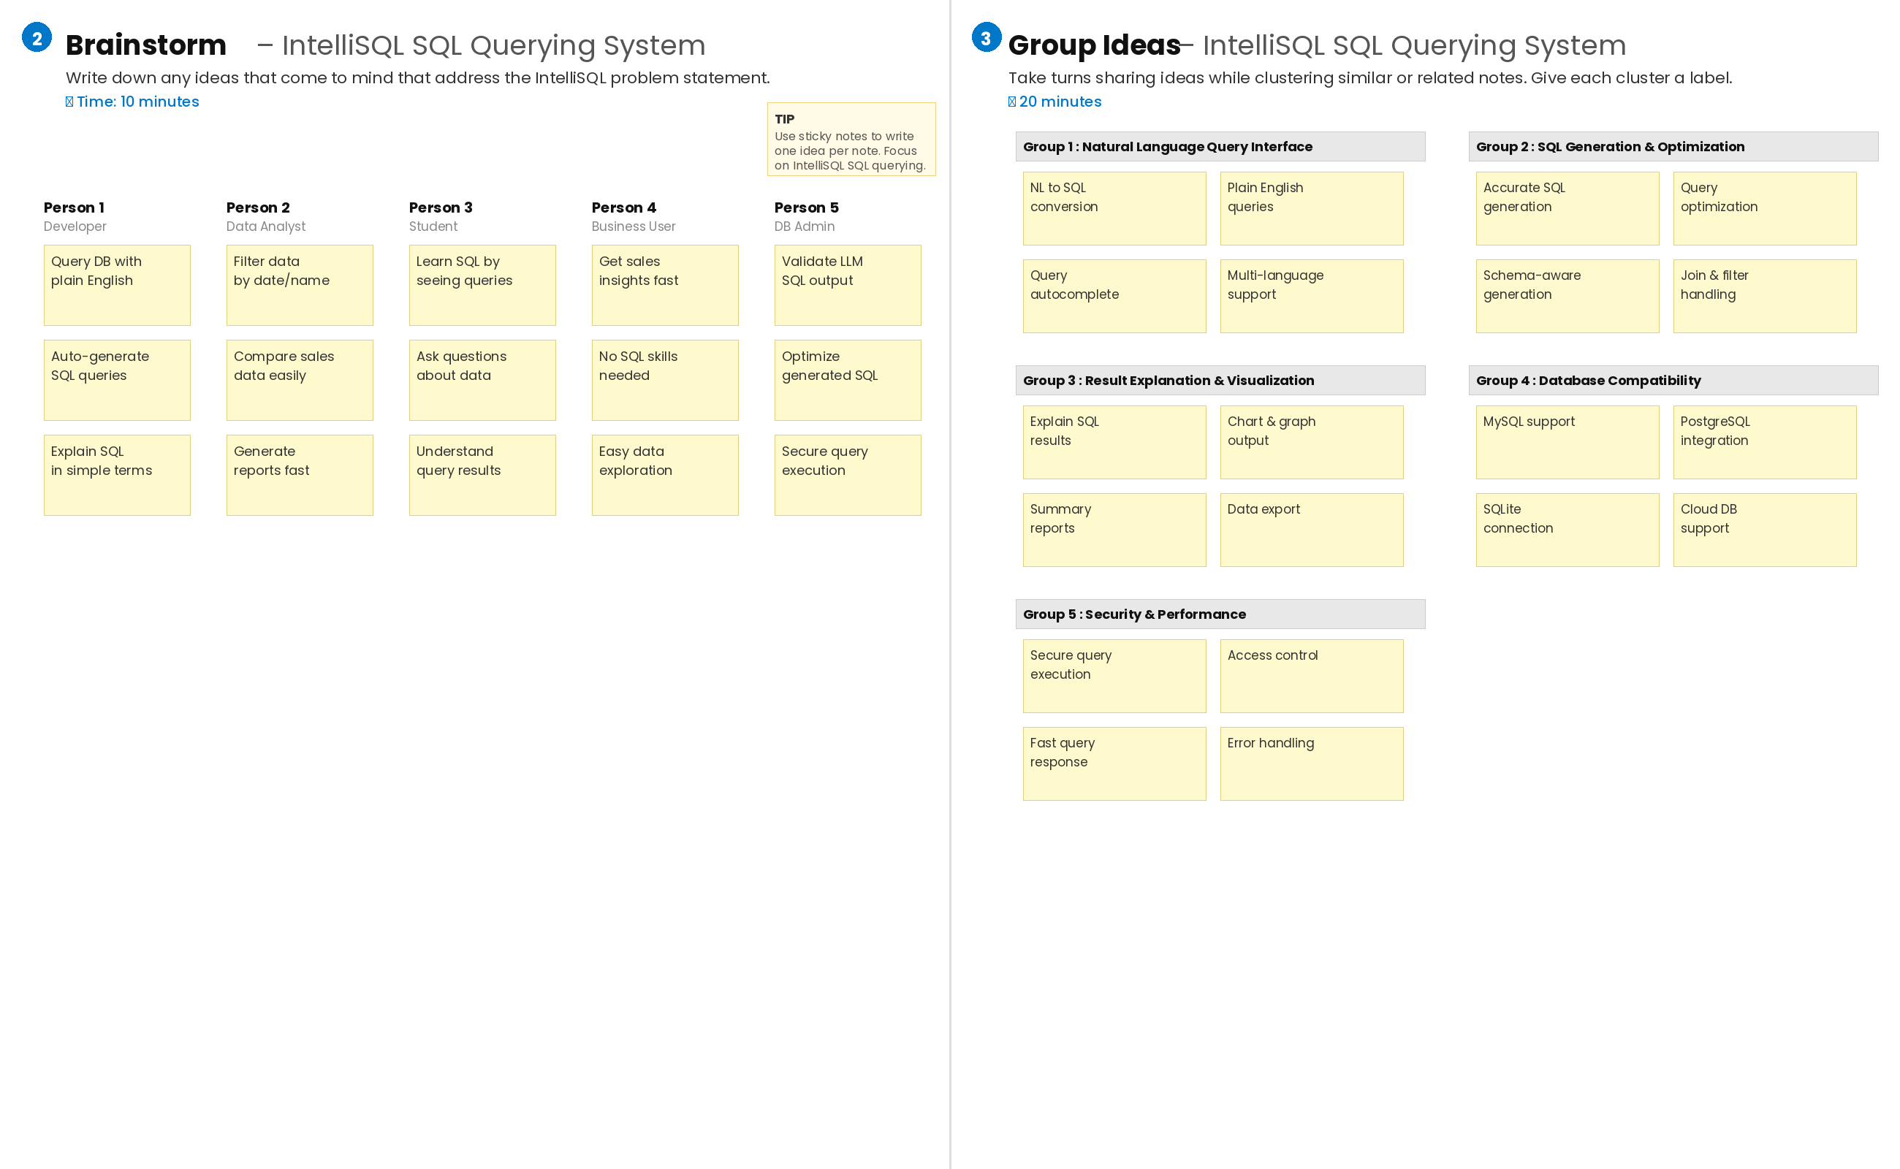
Step-3: Idea Prioritization:

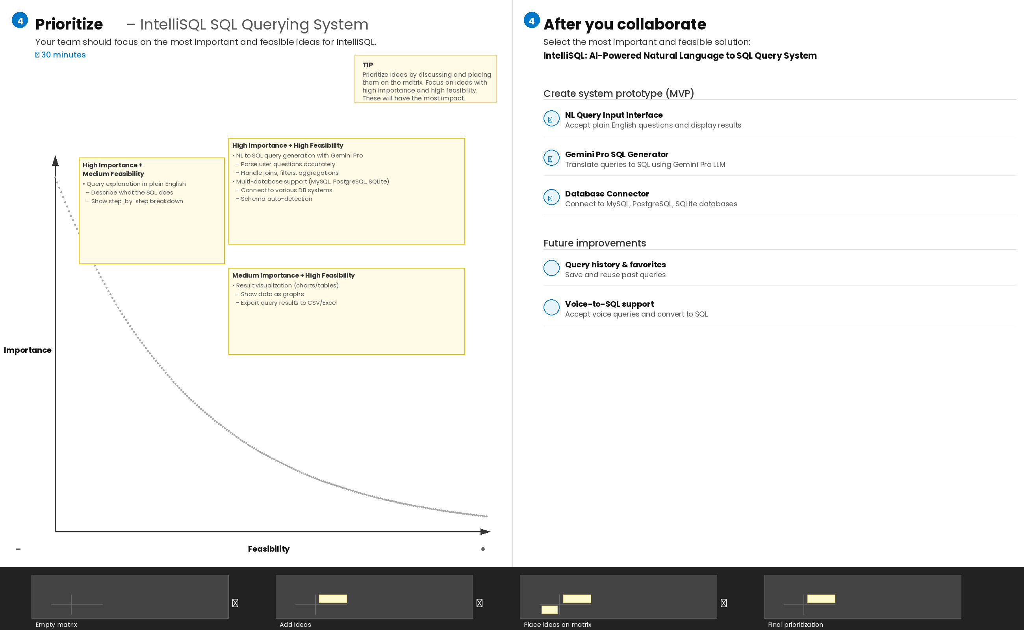
3. Requirement Analysis

3.1. Solution Requirement
Functional Requirements:
Following are the functional requirements of the proposed solution.
FR No. | Functional Requirement (Epic) | Sub Requirement (Story / Sub-Task)
FR-1 | Natural Language input | Accept natural language questions or queries from the user through a web-based interface and pass them to the Gemini Pro LLM
FR-2 | SQL Query Generation | Automatically convert user's natural language input into syntactically correct
FR-3 | Database Schema Integration | Allow users to upload or define their database schema so the LLM can generate context-aware SQL queries
FR-4 ccess, and maintain system security | Query Execution | Execute the generated SQL query against the connected relational database (MySQL / PostgreSQL / SQLite) and retrieve the results for display

Non-functional Requirements:
Following are the non-functional requirements of the proposed solution.
FR No. | Non-Functional Requirement | Description
NFR-1 | Usability | The system shall provide a clean, intuitive, and user-friendly web interface that requires no SQL knowledge, enabling non-technical users
NFR-2 | Reliability | The system shall maintain 99.5% uptime and implement robust error handling to gracefully manage LLM API failures
NFR-3 | Performance | The system shall generate and execute SQL
NFR-4 | Availability | The system shall be accessible 24/7 during academic and production usage with minimal planned
3.2. Data Flow Diagrams
Data Flow Diagrams:
The IntelliSQL System is designed to enable intelligent, natural language-driven SQL querying using Large Language Models (LLMs) powered by Gemini Pro. The system begins with user query inputs, which include natural language questions, database schema context, user credentials, and query preferences. This data is processed by the LLM Query Engine, which serves as the central component
Flow Diagram:
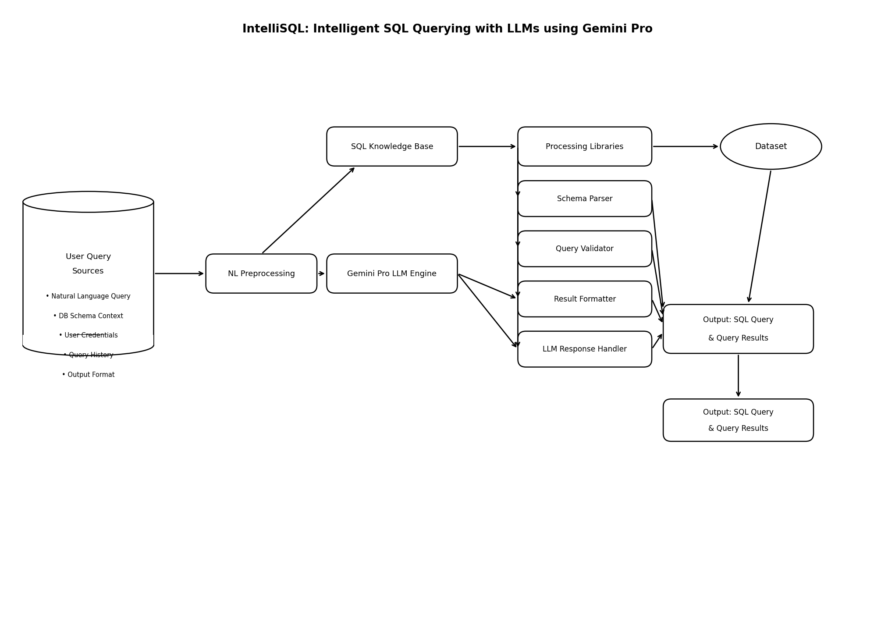
User Stories
Use the below template to list all the user stories for the product.
User Type | Functional Requirement (Epic) | User Story Number | User Story / Task | Acceptance Criteria | Priority | Release
Data Analyst | Natural Language Query Input | USN-1 | As a Data Analyst, I want to enter natural language queries so that the system | System allows artifact upload with name, mission, description, and images. Data is stored securely. | High | Sprint-1
Business User | SQL Query Generation and Access | USN-2 | As a Business User, I want to search and retrieve database records using plain English | System provides accurate artifact search results. Artifact details and images are displayed clearly. | High | Sprint-1
Student / Public User | Query Results Viewing | USN-3 | As a Student, I want to view query results and generated SQL so that I can learn how natural language maps to database queries. | Artifact information is displayed clearly. Images and mission details are accessible. | Medium | Sprint-2
System Administrator | Database Schema Management | USN-4 | As an Administrator, I want to manage artifact records so that the system remains accurate and secure. | Admin can add, edit, and delete artifact records. System maintains data integrity. | High | Sprint-1
Database Admin | Query History | USN-5 | As an Administrator, I want to manage artifact record | System allows preservation status updates. | High | Sprint-2
3.3. Technology Stack
Technical Architecture:
The Deliverable shall include the architectural diagram as below and the
Table-1 : Components & Technologies:

S.No | Component | Description | Technology
1. | User Interface | Critical element designed for users to input natural language queries and receive SQL output, ensuring an intuitive and informative experience | HTML, CSS, JavaScript
2. | Application Logic-1 | Involves a robust backend system responsible for processing natural language queries, calling Gemini Pro API | Python
3. | Database | Involves the storage and management of structured data used to validate and execute. | SQLite / MySQL
4. | File Storage/ Data | Involves managing API calls to Gemini Pro for translating natural language to SQL, including prompt engineering and response parsing. | Google Gemini Pro API
5. | Frame Work | It is a crucial part of our program as it is responsible for connecting the frontend with the backend and routing API requests | Python Flask
Table-2: Application Characteristics:
S.No | Characteristics |  | Description |  | Technology
1. | Open-Source Frameworks | Open-source frameworks accelerate development and ensure the reliability of IntelliSQL's backend pipeline |  | Python’s Flask
2. | Scalability | System can handle increasing query loads and support multiple concurrent users. | REST APIs, load balancing
3. | Performance | Regular performance testing, monitoring, and optimization ensure accurate SQL generation with minimal latency. | Query accuracy metrics, response time benchmarks
4. | Availability | Application can be deployed on cloud or web servers, making it available at all times with minimal downtime. | High speed Linux based webservers.
4. PROJECT DESIGN
4.1. Problem Solution Fit
Problem – Solution Fit Template:
IntelliSQL addresses the critical problem of complex SQL query writing, which remains a significant barrier for non-technical users seeking insights from relational databases. Business analysts, researchers, and domain experts often depend on data engineers to retrieve information, creating bottlenecks and delays
Purpose:
• To enable non-technical users to query relational databases using plain English without writing SQL.
• To leverage Gemini Pro LLM for accurate, context-aware natural language to SQL translation.
• To reduce dependency on data engineers and accelerate data-driven decision making.
• To generate optimized, schema-aware SQL queries with explanations

Template:
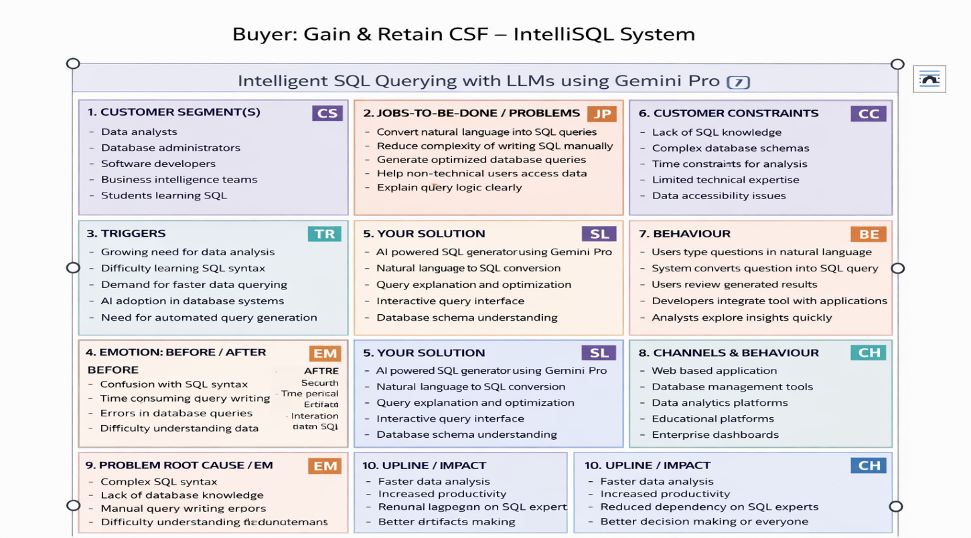
4.2. Proposed Solution
Proposed Solution Template:
Project team shall fill the following information in the proposed solution template.

S.No. | Parameter | Description
1. | Natural Language Input Module | Accept natural language questions from users via a web or CLI interface Parse and pre-process user queries before passing them to the LLM for SQL generation
2. | Gemini Pro LLM Integration | Send parsed natural language queries to the Gemini Pro API for SQL generation Receive SQL statements from the LLM and validate them for correctness and safety
3. | Database Schema Manager | Store and manage database schema metadata including table names, column types, and relationships Provide schema context to Gemini Pro for accurate
4. | SQL Query Execution Engine | Translate user questions into optimized SQL queries using prompt engineering Ensure generated queries are syntactically correct and logically accurate
5. | Results Display and Visualization | User interface to display generated SQL queries and corresponding result sets  Show query output in tabular format
6. | User Authentication and Access Control | Manage users such as data analysts, developers, and administrators Control database access levels
7. | Query History and Performance Monitor | Track all previously executed queries and their execution times Help users refine queries and monitor system performance and LLM response

4.3 Solution Architecture
The solution architecture of IntelliSQL is designed to enable intelligent, natural language-driven SQL query generation using Google’s Gemini Pro large language model. The system begins with the user providing a plain English query along with a database schema. This input is processed through an NLP layer that identifies intent and context, which is then forwarded to the Gemini Pro LLM engine for accurate SQL generation
Solution Architecture:
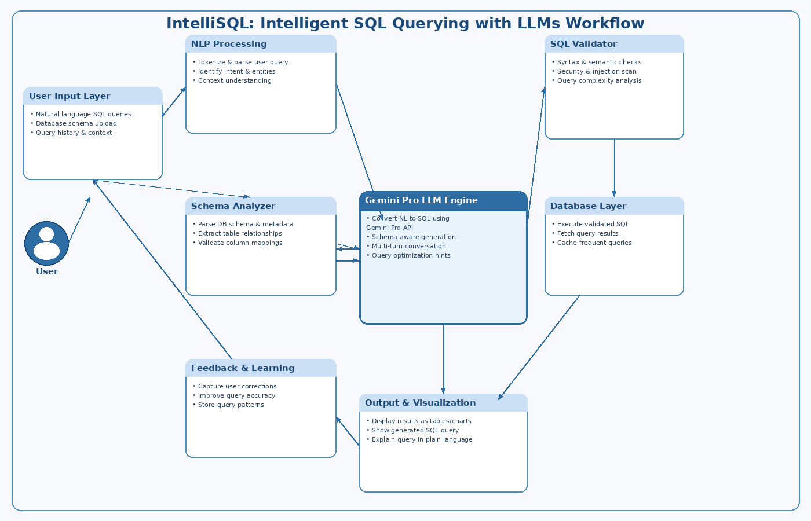

5. PROJECT PLANNING & SCHEDULING
5.1. Project Planning
Product Backlog, Sprint Schedule, and Estimation (4 Marks)
Use the below template to create product backlog and sprint schedule
Sprint | Functional Requirement (Epic) | User Story Number | User Story / Task | Story Points | Priority | Team Members
Sprint-1 | Environment Setup | USN-1 | As a developer, I want to set up the development environment with Python | 2 | High | All Team Members
Sprint-1 | API Configuration | USN-2 | As a developer, I want to configure Google Gemini Pro API with secure | 1 | High | All Team Members
Sprint-2 | Database Creation | USN-3 | As a developer, I want to create SQLite database with sample data for testing | 3 | High | All Team Members
Sprint-2 | Model Integration | USN-4 | As a user, I want the system to translate my natural language questions into SQL . | 3 | High | All Team Members
Sprint-3 | Query Processing | USN-5 | As a user, I want to input natural language queries and receive accurate SQL | 4 | High | All Team Members
Sprint-3 | Result Display | USN-6 | As a user, I want to see query results in a clear, formatted | 2 | Medium | All Team Members
Project Tracker, Velocity & Burndown Chart: (4 Marks)
Sprint | Total Story Points | Duration | Sprint Start Date | Sprint End Date (Planned) | Story Points Complete | Sprint Release Date (Actual)
Sprint 1 | 20 | 4 Days | 28 January 2026 | 31 January 2026 | 20 | 31 January 2026
Sprint 1 | 20 | 4 Days | 28 January 2026 | 31 January 2026 | 20 | 31 January 2026
Sprint 2 | 20 | 8 Days | 02 February 2026 | 09 February 2026 | 20 | 09 February 2026
Sprint 2 | 20 | 8 Days | 02 February 2026 | 09 February 2026 | 20 | 09 February 2026
Sprint 3 | 20 | 7 Days | 12 February 2026 | 18 February 2026 | 20 | 18 February 2026
Sprint 3 | 20 | 7 Days | 12 February 2026 | 18 February 2026 | 20 | 18 February 2026
6. FUNCTIONAL AND PERFORMANCE TESTING
6.1 Performance Testing
Test Scenarios & Results:
Test Case ID | Scenario (What to test) | Test Steps (How to test) | Expected Result | Actual Result | Pass/Fail
FT-01 | Natural Language Query Input | Enter a valid natural language query and submit; also test empty input | Valid query accepted; error shown for empty input | As Expected | Pass
FT-02 | SQL Query Generation via Gemini Pro | Enter a plain English database question and click “Generate SQL” | Syntactically correct SQL query generated and displayed | As Expected | Pass
FT-03 | Gemini Pro API Connection Check | Trigger SQL generation with a valid Gemini Pro API key configured | API responds successfully and returns SQL | As Expected | Pass
FT-04 | Query Result Display & Formatting | Generate SQL and verify output display in the results panel | SQL displayed with proper syntax highlighting | As Expected | Pass
FT-05 | Schema-Aware Query Accuracy | Upload a DB schema and ask schema-specific questions | Correct table and column names used in generated SQL | As Expected | Pass
PT-01 | SQL Response Time Test | Measure time from query submission to SQL output | SQL generated within 3–5 seconds | Within Limit | Pass
PT-02 | Multiple Query Request Handling | Submit multiple SQL queries sequentially without reloading | Application handles all requests without crash or error | Stable | Pass
PT-03 | Deployment Test | Access the deployed IntelliSQL app via browser and run a query | Application loads and SQL generation works correctly online  Correctly give inputs  Check the queries understanding | Working | Pass
7. RESULTS
7.1. Output Screenshots
The complete execution of Intelli sql querying descriptionis represented step by step in the following screenshots.
Step 1: To run the Streamlit Application we have to use the command python streamlit run app.py in the terminal in path where the app.py file is located.
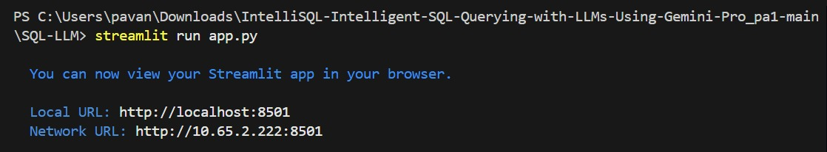
Step 2: After running the command in terminal, the code will get executed and the webpage will open directly. Another way to open webpage is that a localhost link will get generated in the terminal, we can access the webpage using that link.
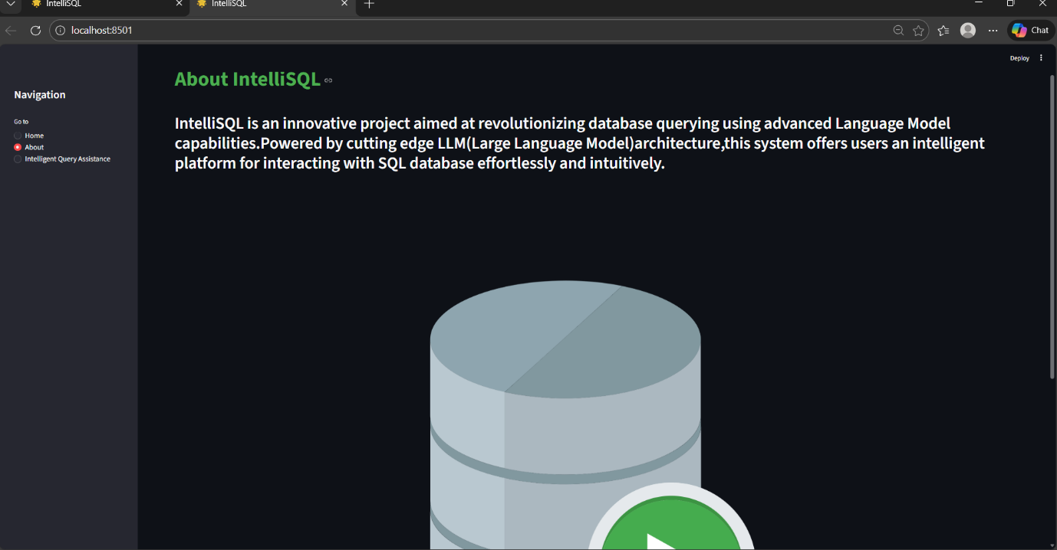

Step 3: The Streamlit webpage opens as shown in the figure given below. This is an automated webpage. No secondary HTML codes required to build this webpage. Python code itself consists the webpage building code.
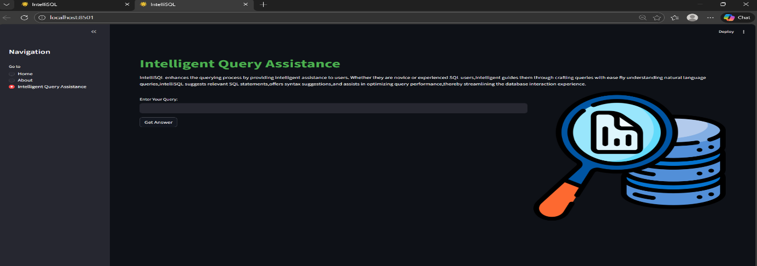

Step 4: After opening this portal it displays the Intelli sql querying Description App, First we should type about any image description what ever we want contant in input prompt . It asks choose any image like wheather location etc. It generate based on the user inputs as shown in the following images
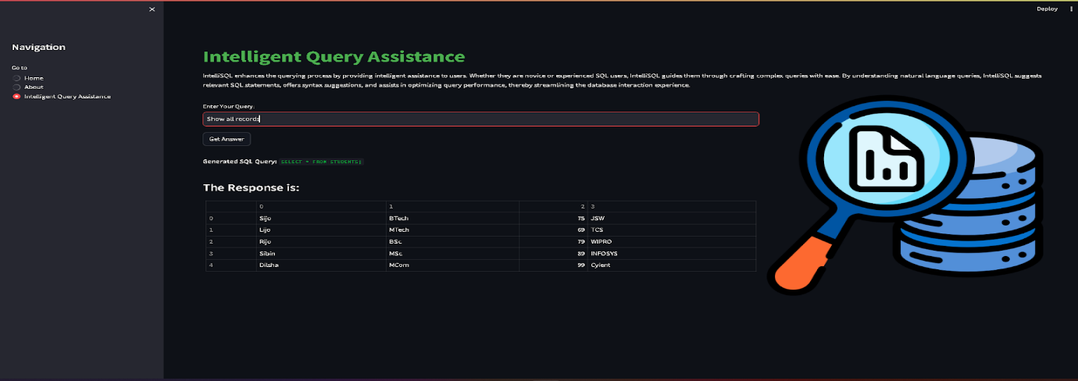

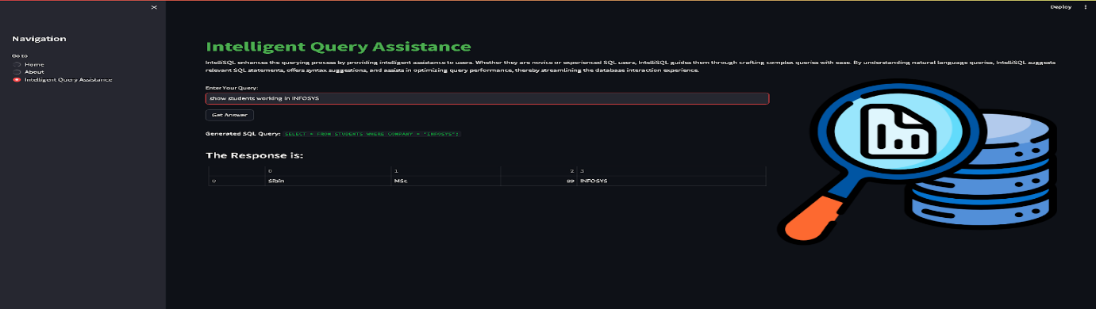

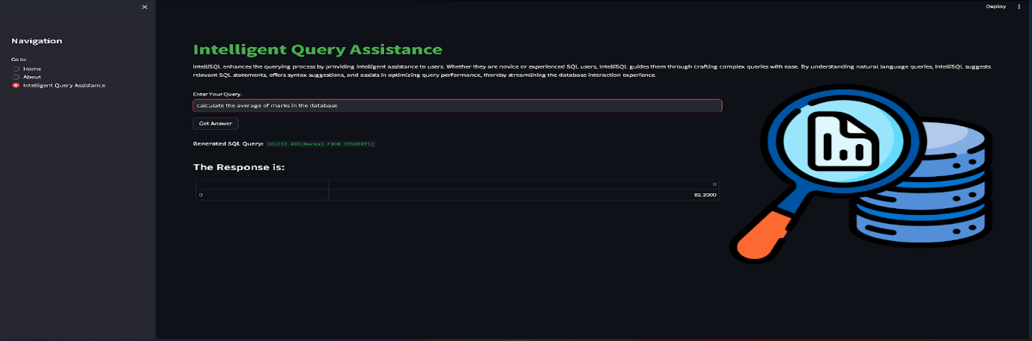

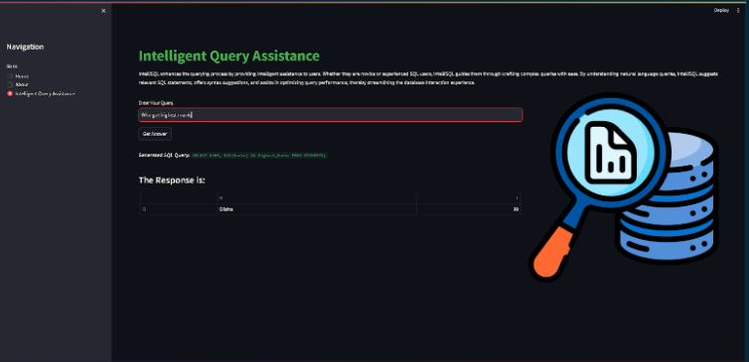

8. ADVANTAGES AND DISADVANTAGES
Advantages
Automatically converts user questions into accurate SQL queries.
• Reduces the need for advanced SQL knowledge.
• Allows users to query databases using simple natural language.
• Saves time compared to manually writing complex queries.
• Improves productivity for analysts, students, and developers.
• Provides quick and meaningful insights from large datasets.
• Can be integrated into web applications, dashboards, and enterprise systems.
Disadvantages
  - Performance depends on the quality of the LLM model.
  - Requires internet connection or API access to Gemini Pro.
  - May struggle with very complex database schemas.
  - Security and data privacy must be handled carefully.
  - Processing large queries may increase response time
  - Generated SQL queries may sometimes be incorrect
  - Natural language questions may be misunderstood sometimes
  - Risk of generating inefficient SQL queries.

9. CONCLUSION
IntelliSQL demonstrates how Large Language Models such as Gemini Pro can simplify database interaction by allowing users to query data using natural language instead of writing complex SQL commands. The system interprets user intent, converts it into accurate SQL queries, executes them on the database, and returns meaningful results.
Github link:
https://github.com/venkatapavan07/Intelligent_SQL_Querying_Pavan.git
Demo link:
https://drive.google.com/file/d/1Q2yQDSiW4oSckBg-dzW7AE-E5jkXzX8Q/view?usp=drivesdk

